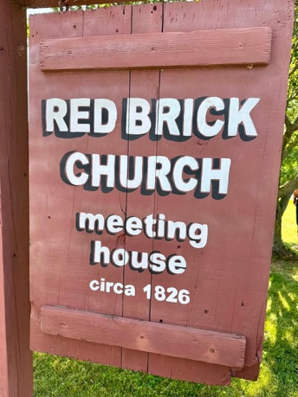
Two Pomeroy Historic Markers were dedicated at the Red Brick Church Meeting House in Sodus Center, NY, on Saturday, July 25th. Thank you to the Pomeroy Foundation, the Town of Sodus Historical Society, and the Baptist Rural Cemetery Association for all their efforts in making these markers a reality. The meeting house was celebrating its 200th anniversary and was decked out in full regalia due to the tender, loving care of its Board. Revolutionary War Patriots who are interred at the Baptist Rural Cemetery were highlighted during the ceremony and include: Thaddeus Bancroft, Samuel Blair, Matthew Clark, Amos Gilbert, Robert McCollum, and Seba Norton.

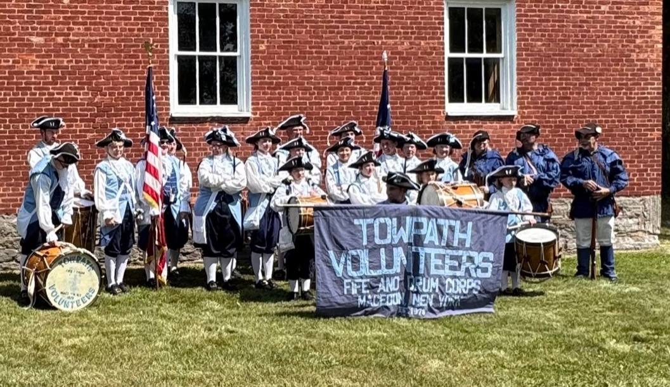
The Towpath Volunteers Fife & Drum Corps provided some wonderful period music, and the finale was a great rendition of Yankee Doodle Dandy after the unveiling of the markers. Brian Manktelow of the 130th Assembly District was in attendance to deliver two citations from the NYS Assembly. This event included some history on each of the Patriots and the meeting house and tours of the meeting house. The Patriots’ graves were marked with balloons for easier
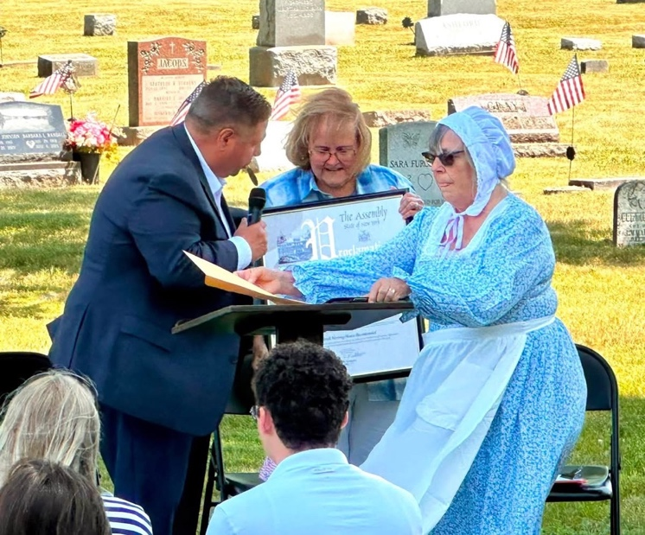
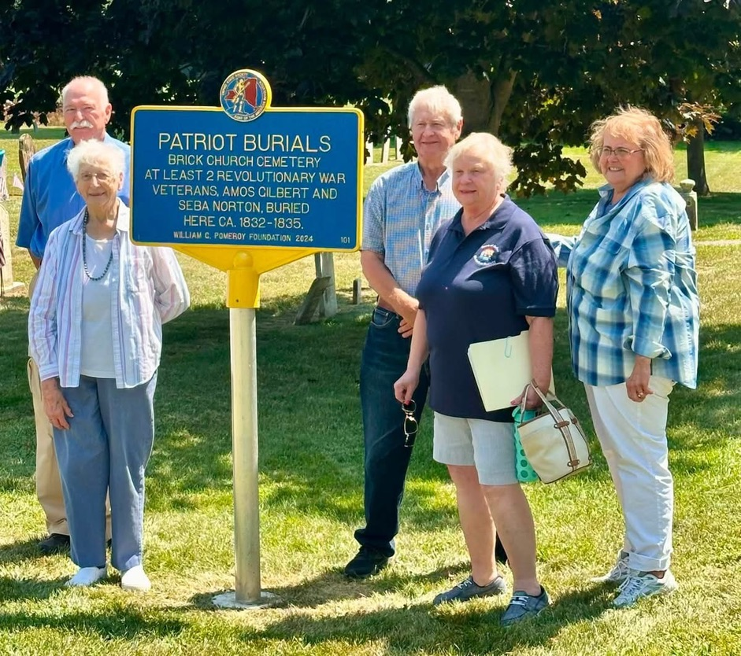
identification, and refreshments were offered at the end of the program. We wish this historic meeting house and its surrounding cemetery a very happy 200th birthday!
Figure 2- Brian Manktelow, Andrea Vermeulen, Patty Paprocki
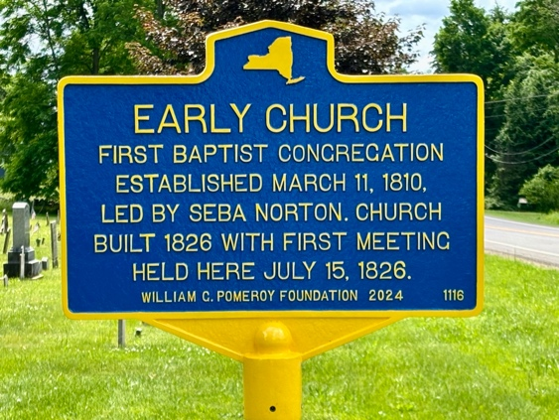

Figure 2- , Janet Wunder, Wayne Vermeulen, Sandra Hamilton, Andrea Vermeulen

